JOURNEYS OF THE MIND

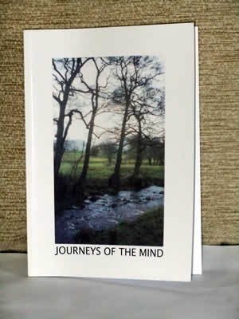
It was in 2001 that Borderland Voices published Landscapes of the Mind. Five years later, we offerered its sequel. We believe that Journeys of the Mind reflects new movements in positive directions both for us as individual artists & writers and for us as an arts and mental health group which is steadily growing in self-confidence and ambition.
The journeys represented here can be seen as both actual and allegorical. The book opens in the safe and familiar surroundings of Leek. Readers are then invited to wind their way through different kinds of childhood towards scenes of instability and uncertainty. Together we can contemplate the dangers of the open country ahead. At first, there are congenial companions on the journey with the offer of light-hearted moments in Rethink gardens at Kniveden and Brough Park, but then the real assault on reason begins. The traveller is attacked from all sides by frightening apparitions and overwhelming emotions – panic, guilt, anger, depression, fear.
Through ownership of these emotions, through the act of artistic expression and through contact with a supportive group, travellers are offered the possibility of creative release and new bearings. They find these, perhaps, at the Dove Valley Centre, in the heart of the rural Moorlands, where, at the end of the book, they arrive at another safe place, twelve miles from Leek.
Borderland Voices is now poised for new ventures. Journeys of the Mind gave rise directly to the innovative Rivers of Life project which drew inspiration from the spectacular scenery of the Staffordshire Moorlands. The newest Borderland Voices initiative is Stepping Stones Arts, a pilot Arts on Referral programme which, in contrast, runs from our new community base at Haregate, Leek. After five years of travelling, it feels good to have a home of our own at last. We are full of hope for a future in which we intend, through our art, to contribute, not just to the mental health of individuals but also, perhaps to the well-being of the wider society. We've touched ground safely.
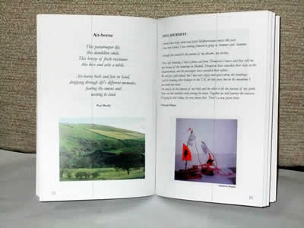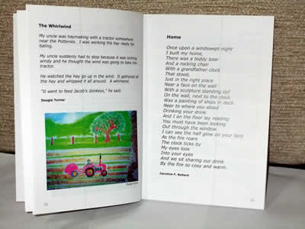
To purchase a copy please e-mail us at: info@borderlandvoices.co.uk
The book is on sale for £5.00 including postage & packing.

